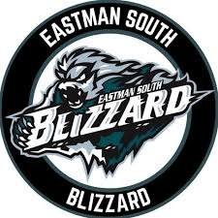

**2024-2025 Eastman South Blizzard AA Tryouts**

We are excited to welcome all players and their families to the 2024-2025 Eastman South Blizzard AA Tryouts!

The U15AA Eastman South Blizzard is now accepting registrations for tryouts for the 2024-2025 season. Players born in 2010-2011 are eligible to try out for this year’s team. **The fee for Phase 1 tryouts will be $125.00 and registration is to be completed on-line through the Eastman registration website.**

**Selection Process:**

**The evaluation process will consist of 3 phases (specific times and details of each phase will be emailed out the beginning of September):**

**Phase 1 – September 21st – 22nd 2024 (Hylife Centre – La Broquerie)**

**Phase 2 – September 26th – 28th 2024 (Hylife Centre – La Broquerie)**

**Phase 3 – October 4th – 6th 2024 (Iles Des Chenes Tournament)**

* **Phase 3 will consist of a mini tournament format between the Jets, Blizzard, Knights and Snipers teams within the AA Division.**
* **This will be the final phase of the tryout process and the Blizzard team will be selected.**
* **The final roster will consist of 15 players and 2 goalies.**

We wish you all the best during the selection process and cannot wait to see you on the ice!